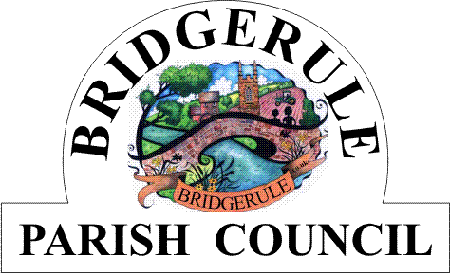

Clerk to the Council: Amanda Harvey e-mail: bridgerulecouncil@outlook.com

To: All Members of Bridgerule Parish Council 13th May 2025

Dear Councillors

You are hereby summoned to attend the ANNUAL MEETING of Bridgerule Parish Council, to be held in the Village Hall, Bridgerule on Tuesday, 20th May 2025, commencing at 7.15 p.m. for the purpose of transacting the following business. In accordance with The Public Bodies (Admissions to Meetings) Act 1960 members of the public are welcome to attend.

Yours sincerely

Amanda Harvey
Parish Clerk
AGENDA

1. To Elect the Chairman for the Year 2025/2026

2. The Chairman Will Read and Sign the Prescribed ‘Declaration of Acceptance of Office’

3. To Elect the Deputy Chairman for the Year 2025/2026

4. Apologies for Absence (Please make any apologies known to the Parish Clerk)

5. Declarations of Interests – to receive declarations of personal and pecuniary interests in respect of items on this Agenda.

5. Council Meeting Minutes – to approve and sign the Minutes of the Council ‘s Annual Meeting held on 23rd May 2024 as a correct record.

6. Matters Arising – to consider matters arising from the Annual Parish Minutes of 20th May 2024 Meeting, not already covered by the Agenda. For information only.

7. Public Open Question Time- To receive questions from the Public. Each member of the public may have up
to 2 minutes time. Standing Orders will be suspended during this session.

8. To Receive Annual Reports from, County Councillor, District Councillor, Chairman, and other
Parish committees or bodies.

9. To Ratify and Adopt the Code of Conduct, Standing orders and Financial Regulations as Prescribed by NALC for the 2025/26 year.

11. To Ratify the Appointment of Gareth Pollard Chartered Accountant as Bridgerule Parish Council’s Accountants for 2025/26 and to Ratify the Insurance for the year 2025/2026 with Community First Ltd

12. To Ratify and adopt the GDPR Policy and Agree Data Protection Officer for the Council for the year 2025/26

13. To approve the Constitution and Risk Assessment for the Bridgerule Open Space Group and the Asset Register for 2025/2026.

14. To Agree and sign the AGAR form for the financial year ended March 2025 and to approve the Annual
Accounts for of year 2024-2025.

15. To Appoint Representatives to the Following Outside Bodies: i. Playground and Open Spaces
ii. Football Club iii. Bridgerule Village Hall Ltd. Iv. Bridgerule Open Space

18. Meeting Close :

